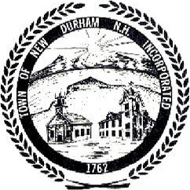
Town of New Durham

Public Notice

Wednesday, December 14, 2011 @ 7 PM @

Turner Application

You are hereby notified that a Public Hearing will be held by the New Durham at 7:00 PM on Wednesday, December 14th, 2011 at the New Durham . The meeting is regarding an application by Chris Berry on behalf of Les Turner for a variance to allow the subdivision of a lot at 210 Route 11, (Map 257-007) that does not meet some of the size and setback requirements of the Zoning Ordinance.

Posted 7/29/2026

The Zoning Board may enter into Non Public Session, if so voted, under the Terms and Conditions of RSA 91-A:3 II a ~ e and RSA 91-A:2 I c.

